SIT 111 COMPUTER SYSTEMS
SUMMARY
MODULE 7,8
WHAT IS A FILE SYSTEM ?
File system is an abstraction that manages the storage and retrieval of data on a computer. It organizes data into files and directories, facilitating easy access and efficient management. The file system acts as a bridge between the user and the computer’s physical hardware, managing how data is stored on drives

The Purpose of File Systems
They give us a simpler way to name and find our data.
They automatically handle the details of which sectors are free or occupied as files are added or removed - think of it as the book updating its own table of contents and index.
They improve performance through techniques like:
Caching: Keeping copies of frequently accessed data for quick access.
Prefetching: Anticipating and loading data that we’re likely to need soon.
They provide reliability. If an app or the OS crashes, or if there’s a sudden power failure, file systems strive to keep our data safe and reduce the risk of corruption.

LET US TAKE A LOOK AT SOME OF THE KEY COMPONENTS OF A FILE SYSTEM
FILES: they are the basic unit of data storage and can contain text, images, programs.
DIRECTORIES: they are used to organise files into a hierarchical structure and they are also known as folders.
FILE PERMISSIONS : it determines who can read, write or execute a file.
METADATA: it contains information about the files and directories like the creation date, type and size.
THERE ARE DIFFERENT TYPES OF FILE SYSTEMS
- FAT- it stands for file allocation table , it is an older type of system used for removable storage.
- NTFS – it stands for new technology file system , and is a modern system used by windows
- ext4 (Fourth Extended Filesystem): Widely used in Linux, known for its robustness and large storage capacity.
- HFS+ (Hierarchical File System Plus): Developed by Apple for macOS, optimized for performance and reliability.
VIRTUAL MACHINES:
A Virtual Machine (VM) is essentially a computer file, often called an image, that behaves like an actual computer. In other words, creating a VM allows you to run an operating system on your existing operating system, just as if you were running a program on your computer. This emulation of a computer system is made possible through a process called virtualization.

THE CONCEPT OF VIRTUALISATION:
Virtualization is the key to the functionality of VMs. It involves creating a virtual version of something, such as hardware platforms, storage devices, or network resources. For VMs, this means simulating a physical computer’s hardware, which allows you to run an operating system and applications in a window on your desktop.

VMs operate by running a virtual copy of a computer system in an isolated environment. This environment is created by virtualization software, often called a hypervisor. The hypervisor allocates physical resources from your computer—like CPU, memory, and storage—to the VM. This makes it possible for the VM to operate independently and isolated from the host system.

PRACTICAL APPLICATIONS:
Virtual Machines have several practical applications, making them an invaluable tool across different sectors of IT:
- Software Development and Testing: Developers use VMs to build and test software in different environments without the need for multiple physical machines.
- Running Multiple Operating Systems: VMs allow you to run different operating systems simultaneously. For instance, you can run Windows on a Mac or vice versa.
- Server Consolidation: In data centres, VMs are used to consolidate multiple servers, reducing physical hardware and improving resource utilization.
DISK IMAGES:
Understanding disk images is an integral component in setting up and using VMs.
A disk image is a file that contains the entire contents and structure representative of a data storage medium or device, such as a hard drive, CD, or DVD. In the context of VMs, a disk image acts as a virtual hard drive. This file encapsulates an entire operating system, applications, and data associated with a VM, essentially serving as the VM’s “physical” storage.
TYPES OF DISK IMAGES:
- ISO Images: Typically used for optical disk images, like CDs and DVDs. They are often used to distribute large software applications and operating systems.
- VDI (VirtualBox Disk Image): Specific to VirtualBox, it’s dynamically allocated, meaning it grows as data is added to it, up to a maximum predefined size.
- VMDK (Virtual Machine Disk): Developed by VMware but compatible with other virtualization software, these are used for VMware virtual machines.
- VHD (Virtual Hard Disk): Developed by Connectix for Microsoft, used by Windows Virtual PC and can be mounted like a physical hard drive in Windows
CREATING A DISK IMAGE:
The process of creating a disk image involves the following steps:
- Choosing the Right Format: Select a disk image format that is compatible with your virtualization software and suits your usage needs.
- Allocating Storage: Decide on the size of your disk image. You can opt for a fixed size, which allocates all the space immediately, or a dynamically allocated size that grows over time.
- Installing an Operating System: Install an operating system on your disk image, just as you would on a physical computer. This can be done by mounting an ISO file or using a physical disk.
COMPARING PHYSICAL AND VIRTUAL MACHINES:
- Resource Allocation:
  - PMs utilize all available resources directly.
  - VMs share the resources of the host machine, with each VM allocated a portion of these resources.
- Performance:
  - PMs typically offer better performance for resource-intensive tasks due to direct hardware access.
  - VM performance may be slightly lower due to the overhead of virtualization.
- Cost and Maintenance:
  - PMs involve higher costs for hardware, energy, and physical space.
  - VMs reduce physical hardware needs, leading to cost savings in hardware investment and maintenance.
- Scalability and Deployment:
  - Scaling PMs often requires additional physical hardware.
  - VMs can be quickly scaled or deployed as they do not require additional physical hardware.
ACTIVITIES:
ACTIVITY 7:
PART 1:
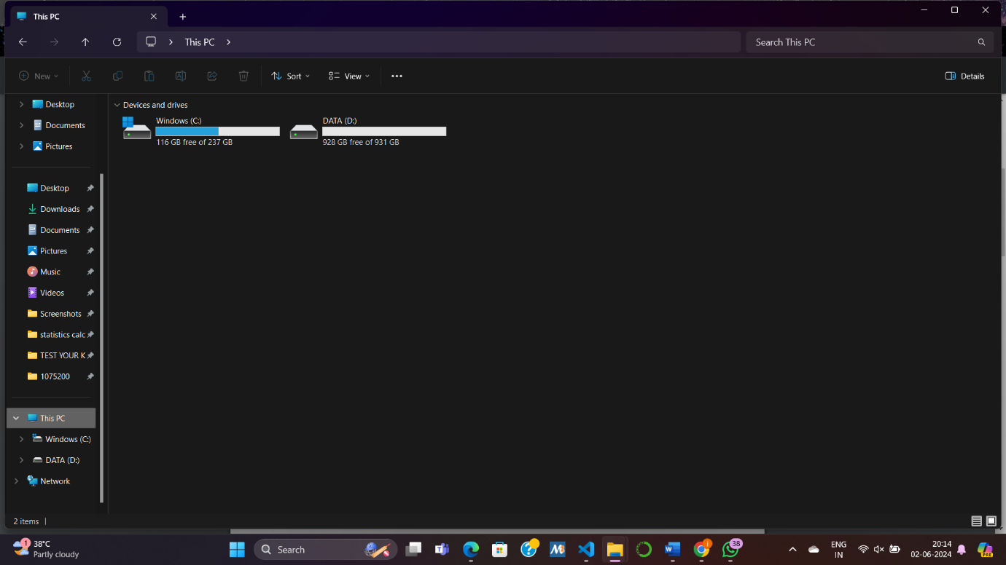
FILE EXPLORER:

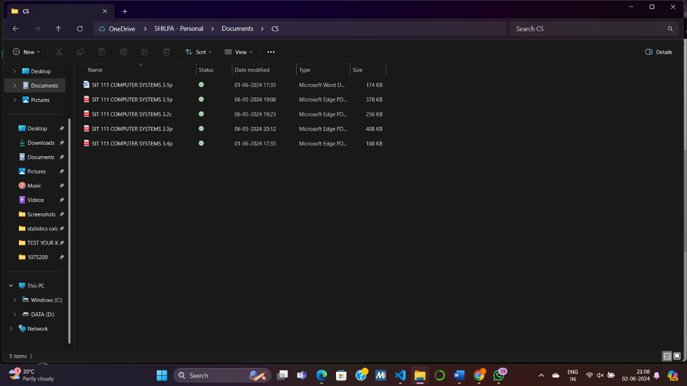
COMPUTER SYSTEMS FOLDER:

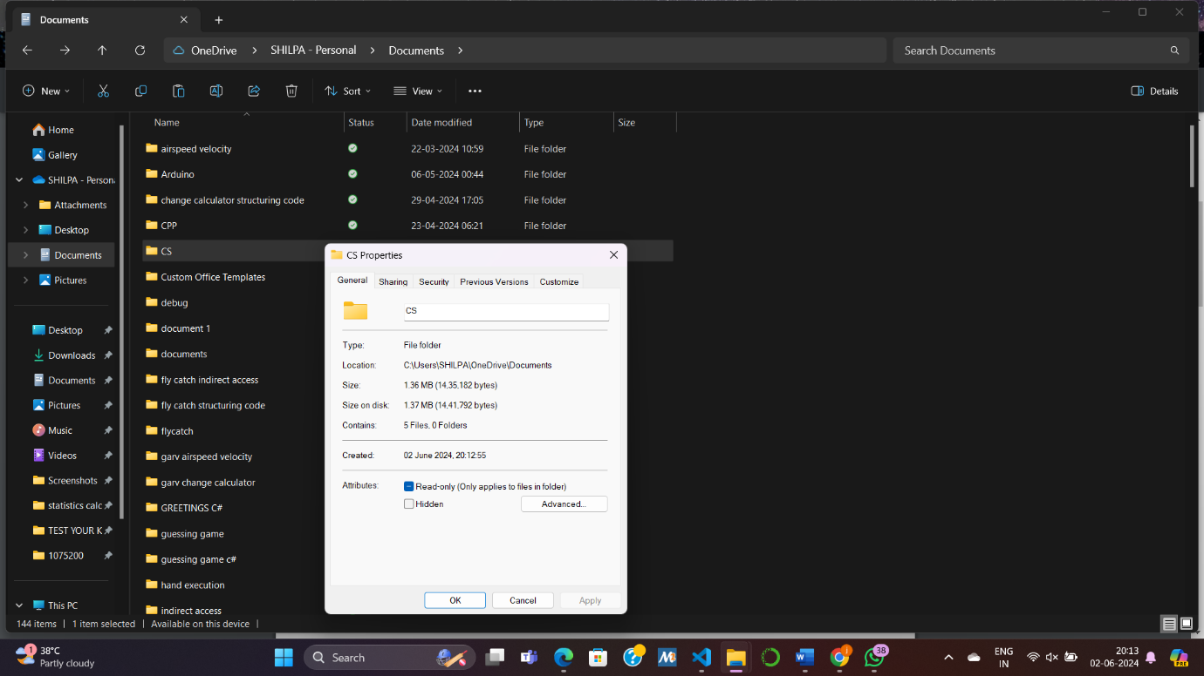
PART 2:
- Provides artists with a fresh revenue stream.
- Ensures immutability of digital assets.
- Utilizes smart contracts to facilitate transactions.
- Fosters a sense of ownership, pride, and dedication to the arts.
Disadvantages of the New Technology File System (NFTS):
- The NFT market is predominantly speculative.
- NFTs are susceptible to theft.
- Uncertainty exists regarding the future sustainability of NFTs.
- A distinction exists between ownership and control over NFTs.
ACTIVITY 8 :
INSTALLING VIRTUAL BOX:
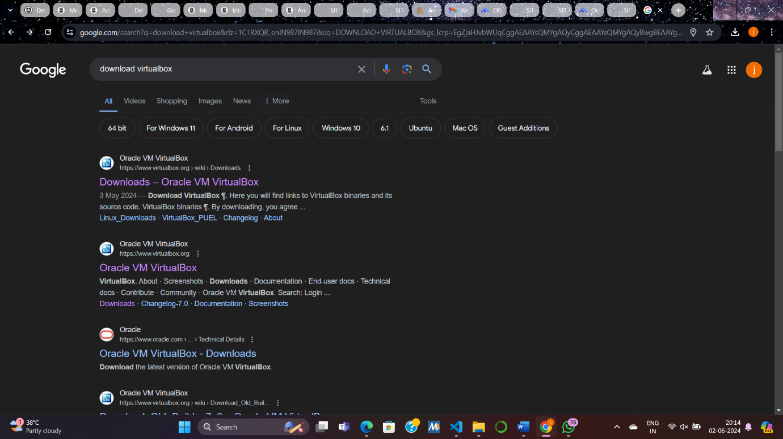
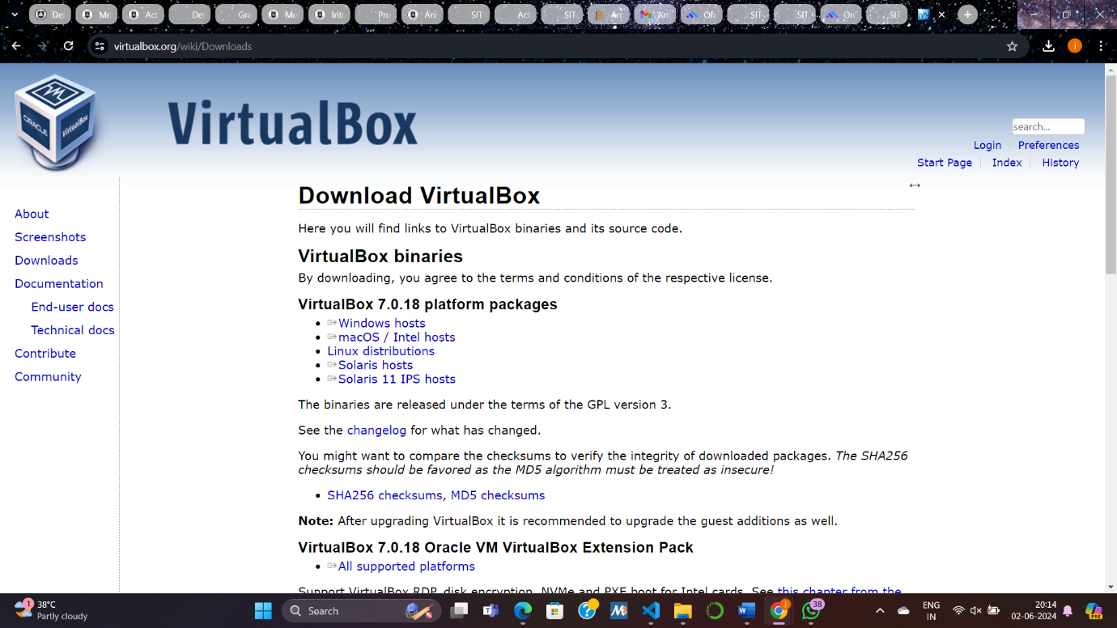
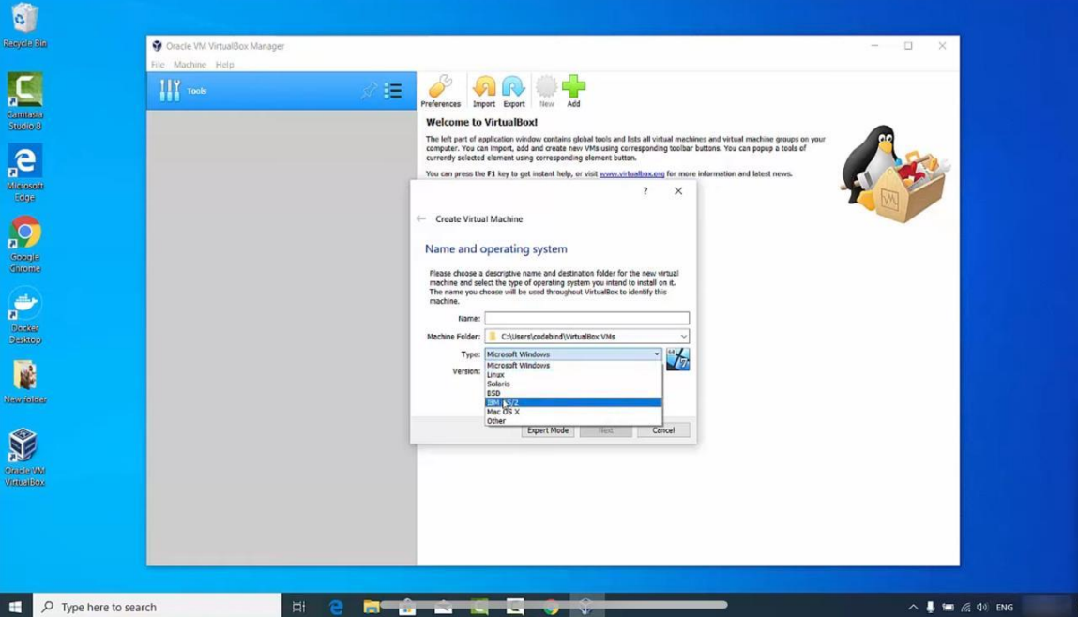
QUIZ RESULTS:
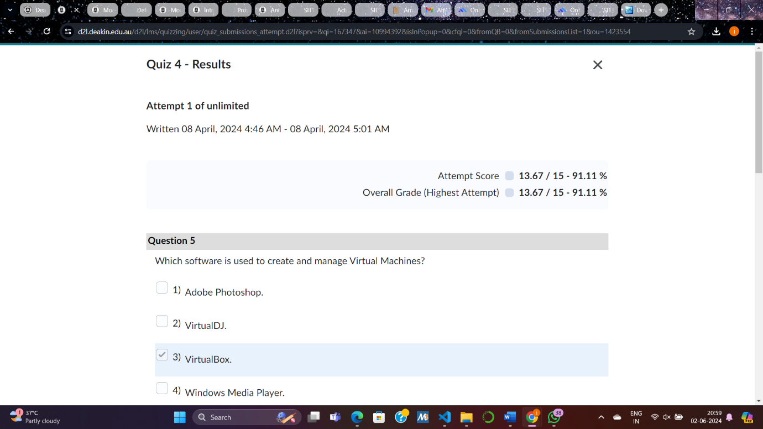

REFLECTIONS:
How do you know you achieved the learning goals?
I can gauge my achievement of learning goals by assessing my understanding and proficiency in the topics covered. This includes being able to explain concepts such as file systems, virtual machines, and disk images, as well as understanding their practical applications and significance in computing.
What is the most important things you learned from these and why?
The most important thing I learned from these topics is the fundamental role that file systems play in managing data storage and retrieval on a computer. Understanding concepts like directories, file permissions, and metadata provides insights into how data is organized and accessed, which is essential for efficient computing practices. Additionally, learning about virtual machines and disk images expanded my knowledge of virtualization technology, which is increasingly important in modern computing environments due to its versatility and resource optimization capabilities.
How does the content or skills learned here relate to the things you already known
The content and skills learned here build upon my existing knowledge of computer systems and software. For example, understanding file systems enhances my comprehension of operating systems and storage management, while knowledge of virtual machines expands my understanding of system architecture and virtualization technologies. Overall, these topics complement and deepen my existing knowledge in the field of computer science and technology.

